GET
FILE='C:\Users\user\Documents\NILAY\Mayis2020\7_NSGAII.sav'.
DATASET NAME DataSet2 WINDOW=FRONT.
DATASET CLOSE DataSet1.
GLM HV EP GD IGD IGDplus SPREAD BY Crossover MaxEvaluations PopulationSize
/METHOD=SSTYPE(3)
/INTERCEPT=INCLUDE
/POSTHOC=Crossover MaxEvaluations PopulationSize(BONFERRONI)
/PLOT=PROFILE(Crossover MaxEvaluations PopulationSize)
/CRITERIA=ALPHA(.05)
/DESIGN=Crossover MaxEvaluations PopulationSize.

General Linear Model

Notes
Output Created |  | 26-MAY-2020 20:19:05
Comments
Input | Data | C:\Users\user\Documents\NILAY\Mayis2020\7_NSGAII.sav
Input | Active Dataset | DataSet2
Input | Filter | <none>
Input | Weight | <none>
Input | Split File | <none>
Input | N of Rows in Working Data File | 837
Missing Value Handling | Definition of Missing | User-defined missing values are treated as missing.
Missing Value Handling | Cases Used | Statistics are based on all cases with valid data for all variables in the model.
Syntax |  | GLM HV EP GD IGD IGDplus SPREAD BY Crossover MaxEvaluations PopulationSize  /METHOD=SSTYPE(3)  /INTERCEPT=INCLUDE  /POSTHOC=Crossover MaxEvaluations PopulationSize(BONFERRONI)  /PLOT=PROFILE(Crossover MaxEvaluations PopulationSize)  /CRITERIA=ALPHA(.05)  /DESIGN=Crossover MaxEvaluations PopulationSize.
Resources | Processor Time | 00:00:03.17
Resources | Elapsed Time | 00:00:03.13

[DataSet2] C:\Users\user\Documents\NILAY\Mayis2020\7_NSGAII.sav

Between-Subjects Factors
 |  | Value Label | N
Crossover | 1 | 0.7 | 279
Crossover | 2 | 0.8 | 279
Crossover | 3 | 0.9 | 279
MaxEvaluations | 1 | 15000 | 279
MaxEvaluations | 2 | 20000 | 279
MaxEvaluations | 3 | 25000 | 279
PopulationSize | 1 | 100 | 279
PopulationSize | 2 | 50 | 279
PopulationSize | 3 | 200 | 279

Multivariate Testsª
Effect |  | Value | F | Hypothesis df | Error df
Intercept | Pillai's Trace | 1.000 | 10235110.680^{b} | 5.000 | 826.000
Intercept | Wilks' Lambda | .000 | 10235110.680^{b} | 5.000 | 826.000
Intercept | Hotelling's Trace | 61955.876 | 10235110.680^{b} | 5.000 | 826.000
Intercept | Roy's Largest Root | 61955.876 | 10235110.680^{b} | 5.000 | 826.000
Crossover | Pillai's Trace | .019 | 1.579 | 10.000 | 1654.000
Crossover | Wilks' Lambda | .981 | 1.578^{b} | 10.000 | 1652.000
Crossover | Hotelling's Trace | .019 | 1.577 | 10.000 | 1650.000
Crossover | Roy's Largest Root | .013 | 2.121^{c} | 5.000 | 827.000
MaxEvaluations | Pillai's Trace | .016 | 1.344 | 10.000 | 1654.000
MaxEvaluations | Wilks' Lambda | .984 | 1.344^{b} | 10.000 | 1652.000
MaxEvaluations | Hotelling's Trace | .016 | 1.343 | 10.000 | 1650.000
MaxEvaluations | Roy's Largest Root | .012 | 1.976^{c} | 5.000 | 827.000
PopulationSize | Pillai's Trace | .538 | 60.813 | 10.000 | 1654.000
PopulationSize | Wilks' Lambda | .468 | 76.361^{b} | 10.000 | 1652.000
PopulationSize | Hotelling's Trace | 1.127 | 92.950 | 10.000 | 1650.000
PopulationSize | Roy's Largest Root | 1.116 | 184.652^{c} | 5.000 | 827.000

Multivariate Testsª
Effect |  | Sig.
Intercept | Pillai's Trace | .000
Intercept | Wilks' Lambda | .000
Intercept | Hotelling's Trace | .000
Intercept | Roy's Largest Root | .000
Crossover | Pillai's Trace | .107
Crossover | Wilks' Lambda | .107
Crossover | Hotelling's Trace | .108
Crossover | Roy's Largest Root | .061
MaxEvaluations | Pillai's Trace | .201
MaxEvaluations | Wilks' Lambda | .201
MaxEvaluations | Hotelling's Trace | .202
MaxEvaluations | Roy's Largest Root | .080
PopulationSize | Pillai's Trace | .000
PopulationSize | Wilks' Lambda | .000
PopulationSize | Hotelling's Trace | .000
PopulationSize | Roy's Largest Root | .000

a. Design: Intercept + Crossover + MaxEvaluations + PopulationSize
b. Exact statistic
c. The statistic is an upper bound on F that yields a lower bound on the significance level.

Tests of Between-Subjects Effects
Source | Dependent Variable | Type III Sum of Squares | df | Mean Square | F
Corrected Model | HV | .760ª | 6 | .127 | 15.503
Corrected Model | EP | .760^{b} | 6 | .127 | 15.503
Corrected Model | GD | .403^{c} | 6 | .067 | 53.619
Corrected Model | IGD | .368^{d} | 6 | .061 | 2.503
Corrected Model | IGDplus | .390e | 6 | .065 | 14.134
Corrected Model | SPREAD | 1.368^{f} | 6 | .228 | 6.288
Intercept | HV | 741.771 | 1 | 741.771 | 90753.901
Intercept | EP | 2.875 | 1 | 2.875 | 351.705
Intercept | GD | 5.191 | 1 | 5.191 | 4147.258
Intercept | IGD | 326.522 | 1 | 326.522 | 13340.602
Intercept | IGDplus | 1.183 | 1 | 1.183 | 257.551
Intercept | SPREAD | 1244.731 | 1 | 1244.731 | 34338.780
Crossover | HV | .017 | 2 | .008 | 1.039
Crossover | EP | .017 | 2 | .008 | 1.039
Crossover | GD | .008 | 2 | .004 | 3.035
Crossover | IGD | .184 | 2 | .092 | 3.754
Crossover | IGDplus | .008 | 2 | .004 | .885
Crossover | SPREAD | .274 | 2 | .137 | 3.786
MaxEvaluations | HV | .032 | 2 | .016 | 1.957
MaxEvaluations | EP | .032 | 2 | .016 | 1.957
MaxEvaluations | GD | .002 | 2 | .001 | .805
MaxEvaluations | IGD | .001 | 2 | .001 | .021
MaxEvaluations | IGDplus | .017 | 2 | .009 | 1.893
MaxEvaluations | SPREAD | .007 | 2 | .003 | .093
PopulationSize | HV | .711 | 2 | .356 | 43.511
PopulationSize | EP | .711 | 2 | .356 | 43.511
PopulationSize | GD | .393 | 2 | .197 | 157.017
PopulationSize | IGD | .183 | 2 | .091 | 3.734
PopulationSize | IGDplus | .364 | 2 | .182 | 39.624
PopulationSize | SPREAD | 1.086 | 2 | .543 | 14.986
Error | HV | 6.784 | 830 | .008
Error | EP | 6.784 | 830 | .008
Error | GD | 1.039 | 830 | .001
Error | IGD | 20.315 | 830 | .024
Error | IGDplus | 3.814 | 830 | .005

Tests of Between-Subjects Effects
Source | Dependent Variable | Sig.
Corrected Model | HV | .000ª
Corrected Model | EP | .000^{b}
Corrected Model | GD | .000^{c}
Corrected Model | IGD | .021^{d}
Corrected Model | IGDplus | .000e
Corrected Model | SPREAD | .000^{f}
Intercept | HV | .000
Intercept | EP | .000
Intercept | GD | .000
Intercept | IGD | .000
Intercept | IGDplus | .000
Intercept | SPREAD | .000
Crossover | HV | .354
Crossover | EP | .354
Crossover | GD | .049
Crossover | IGD | .024
Crossover | IGDplus | .413
Crossover | SPREAD | .023
MaxEvaluations | HV | .142
MaxEvaluations | EP | .142
MaxEvaluations | GD | .447
MaxEvaluations | IGD | .980
MaxEvaluations | IGDplus | .151
MaxEvaluations | SPREAD | .912
PopulationSize | HV | .000
PopulationSize | EP | .000
PopulationSize | GD | .000
PopulationSize | IGD | .024
PopulationSize | IGDplus | .000
PopulationSize | SPREAD | .000
Error | HV
Error | EP
Error | GD
Error | IGD
Error | IGDplus

Tests of Between-Subjects Effects
Source | Dependent Variable | Type III Sum of Squares | df | Mean Square | F
Error | SPREAD | 30.086ª | 830 | .036
Total | HV | 749.315^{b} | 837
Total | EP | 10.419^{c} | 837
Total | GD | 6.632^{d} | 837
Total | IGD | 347.205e | 837
Total | IGDplus | 5.387^{f} | 837
Total | SPREAD | 1276.185 | 837
Corrected Total | HV | 7.544 | 836
Corrected Total | EP | 7.544 | 836
Corrected Total | GD | 1.441 | 836
Corrected Total | IGD | 20.682 | 836
Corrected Total | IGDplus | 4.203 | 836
Corrected Total | SPREAD | 31.454 | 836

Tests of Between-Subjects Effects
Source | Dependent Variable | Sig.
Error | SPREAD
Total | HV
Total | EP
Total | GD
Total | IGD
Total | IGDplus
Total | SPREAD
Corrected Total | HV
Corrected Total | EP
Corrected Total | GD
Corrected Total | IGD
Corrected Total | IGDplus
Corrected Total | SPREAD

a. R Squared = .101 (Adjusted R Squared = .094)
b. R Squared = .101 (Adjusted R Squared = .094)
c. R Squared = .279 (Adjusted R Squared = .274)
d. R Squared = .018 (Adjusted R Squared = .011)
e. R Squared = .093 (Adjusted R Squared = .086)
f. R Squared = .043 (Adjusted R Squared = .037)

Post Hoc Tests

Crossover

Multiple Comparisons
Bonferroni
Dependent Variable | (I) Crossover | (J) Crossover | Mean Difference (I-J) | Std. Error | Sig.
HV | 0.7 | 0.8 | -.0042 | .00765 | 1.000
HV | 0.7 | 0.9 | -.0109 | .00765 | .460
HV | 0.8 | 0.7 | .0042 | .00765 | 1.000
HV | 0.8 | 0.9 | -.0067 | .00765 | 1.000
HV | 0.9 | 0.7 | .0109 | .00765 | .460
HV | 0.9 | 0.8 | .0067 | .00765 | 1.000
EP | 0.7 | 0.8 | .0042 | .00765 | 1.000
EP | 0.7 | 0.9 | .0109 | .00765 | .460
EP | 0.8 | 0.7 | -.0042 | .00765 | 1.000
EP | 0.8 | 0.9 | .0067 | .00765 | 1.000
EP | 0.9 | 0.7 | -.0109 | .00765 | .460
EP | 0.9 | 0.8 | -.0067 | .00765 | 1.000
GD | 0.7 | 0.8 | .0071 | .00300 | .053
GD | 0.7 | 0.9 | .0053 | .00300 | .239
GD | 0.8 | 0.7 | -.0071 | .00300 | .053
GD | 0.8 | 0.9 | -.0019 | .00300 | 1.000
GD | 0.9 | 0.7 | -.0053 | .00300 | .239
GD | 0.9 | 0.8 | .0019 | .00300 | 1.000
IGD | 0.7 | 0.8 | .0209 | .01325 | .346
IGD | 0.7 | 0.9 | .0362* | .01325 | .019
IGD | 0.8 | 0.7 | -.0209 | .01325 | .346
IGD | 0.8 | 0.9 | .0153 | .01325 | .748
IGD | 0.9 | 0.7 | -.0362* | .01325 | .019
IGD | 0.9 | 0.8 | -.0153 | .01325 | .748
IGDplus | 0.7 | 0.8 | .0029 | .00574 | 1.000
IGDplus | 0.7 | 0.9 | .0076 | .00574 | .564
IGDplus | 0.8 | 0.7 | -.0029 | .00574 | 1.000
IGDplus | 0.8 | 0.9 | .0047 | .00574 | 1.000
IGDplus | 0.9 | 0.7 | -.0076 | .00574 | .564
IGDplus | 0.9 | 0.8 | -.0047 | .00574 | 1.000
SPREAD | 0.7 | 0.8 | -.0065 | .01612 | 1.000
SPREAD | 0.7 | 0.9 | -.0412* | .01612 | .032
SPREAD | 0.8 | 0.7 | .0065 | .01612 | 1.000

Multiple Comparisons
Bonferroni
Dependent Variable | (I) Crossover | (J) Crossover | 95% Confidence Interval
Dependent Variable | (I) Crossover | (J) Crossover | Lower Bound | Upper Bound
HV | 0.7 | 0.8 | -.0226 | .0142
HV | 0.7 | 0.9 | -.0293 | .0074
HV | 0.8 | 0.7 | -.0142 | .0226
HV | 0.8 | 0.9 | -.0251 | .0116
HV | 0.9 | 0.7 | -.0074 | .0293
HV | 0.9 | 0.8 | -.0116 | .0251
EP | 0.7 | 0.8 | -.0142 | .0226
EP | 0.7 | 0.9 | -.0074 | .0293
EP | 0.8 | 0.7 | -.0226 | .0142
EP | 0.8 | 0.9 | -.0116 | .0251
EP | 0.9 | 0.7 | -.0293 | .0074
EP | 0.9 | 0.8 | -.0251 | .0116
GD | 0.7 | 0.8 | -.0001 | .0143
GD | 0.7 | 0.9 | -.0019 | .0124
GD | 0.8 | 0.7 | -.0143 | .0001
GD | 0.8 | 0.9 | -.0090 | .0053
GD | 0.9 | 0.7 | -.0124 | .0019
GD | 0.9 | 0.8 | -.0053 | .0090
IGD | 0.7 | 0.8 | -.0109 | .0527
IGD | 0.7 | 0.9 | .0044* | .0679
IGD | 0.8 | 0.7 | -.0527 | .0109
IGD | 0.8 | 0.9 | -.0165 | .0470
IGD | 0.9 | 0.7 | -.0679* | -.0044
IGD | 0.9 | 0.8 | -.0470 | .0165
IGDplus | 0.7 | 0.8 | -.0109 | .0166
IGDplus | 0.7 | 0.9 | -.0062 | .0213
IGDplus | 0.8 | 0.7 | -.0166 | .0109
IGDplus | 0.8 | 0.9 | -.0091 | .0185
IGDplus | 0.9 | 0.7 | -.0213 | .0062
IGDplus | 0.9 | 0.8 | -.0185 | .0091
SPREAD | 0.7 | 0.8 | -.0452 | .0322
SPREAD | 0.7 | 0.9 | -.0799* | -.0026
SPREAD | 0.8 | 0.7 | -.0322 | .0452

Multiple Comparisons
Bonferroni
Dependent Variable | (I) Crossover | (J) Crossover | Mean Difference (I-J) | Std. Error | Sig.
SPREAD | 0.8 | 0.9 | -.0347 | .01612 | .094
SPREAD | 0.9 | 0.7 | .0412 | .01612 | .032
SPREAD | 0.9 | 0.8 | .0347 | .01612 | .094

Multiple Comparisons
Bonferroni
Dependent Variable | (I) Crossover | (J) Crossover | 95% Confidence Interval
Dependent Variable | (I) Crossover | (J) Crossover | Lower Bound | Upper Bound
SPREAD | 0.8 | 0.9 | -.0734 | .0039
SPREAD | 0.9 | 0.7 | .0026 | .0799
SPREAD | 0.9 | 0.8 | -.0039 | .0734

Based on observed means.
The error term is Mean Square(Error) = .036.
*. The mean difference is significant at the .05 level.

Homogeneous Subsets

MaxEvaluations

Multiple Comparisons
Bonferroni
Dependent Variable | (I) MaxEvaluations | (J) MaxEvaluations | Mean Difference (I-J) | Std. Error | Sig.
HV | 15000 | 20000 | -.0092 | .00765 | .688
HV | 15000 | 25000 | -.0150 | .00765 | .150
HV | 20000 | 15000 | .0092 | .00765 | .688
HV | 20000 | 25000 | -.0058 | .00765 | 1.000
HV | 25000 | 15000 | .0150 | .00765 | .150
HV | 25000 | 20000 | .0058 | .00765 | 1.000
EP | 15000 | 20000 | .0092 | .00765 | .688
EP | 15000 | 25000 | .0150 | .00765 | .150
EP | 20000 | 15000 | -.0092 | .00765 | .688
EP | 20000 | 25000 | .0058 | .00765 | 1.000
EP | 25000 | 15000 | -.0150 | .00765 | .150
EP | 25000 | 20000 | -.0058 | .00765 | 1.000
GD | 15000 | 20000 | .0006 | .00300 | 1.000
GD | 15000 | 25000 | -.0029 | .00300 | .979
GD | 20000 | 15000 | -.0006 | .00300 | 1.000
GD | 20000 | 25000 | -.0036 | .00300 | .707
GD | 25000 | 15000 | .0029 | .00300 | .979
GD | 25000 | 20000 | .0036 | .00300 | .707
IGD | 15000 | 20000 | -.0026 | .01325 | 1.000
IGD | 15000 | 25000 | -.0019 | .01325 | 1.000
IGD | 20000 | 15000 | .0026 | .01325 | 1.000
IGD | 20000 | 25000 | .0007 | .01325 | 1.000
IGD | 25000 | 15000 | .0019 | .01325 | 1.000
IGD | 25000 | 20000 | -.0007 | .01325 | 1.000
IGDplus | 15000 | 20000 | .0072 | .00574 | .622
IGDplus | 15000 | 25000 | .0110 | .00574 | .168
IGDplus | 20000 | 15000 | -.0072 | .00574 | .622
IGDplus | 20000 | 25000 | .0037 | .00574 | 1.000
IGDplus | 25000 | 15000 | -.0110 | .00574 | .168
IGDplus | 25000 | 20000 | -.0037 | .00574 | 1.000
SPREAD | 15000 | 20000 | -.0020 | .01612 | 1.000
SPREAD | 15000 | 25000 | -.0067 | .01612 | 1.000
SPREAD | 20000 | 15000 | .0020 | .01612 | 1.000

Multiple Comparisons
Bonferroni
Dependent Variable | (I) MaxEvaluations | (J) MaxEvaluations | 95% Confidence Interval
Dependent Variable | (I) MaxEvaluations | (J) MaxEvaluations | Lower Bound | Upper Bound
HV | 15000 | 20000 | -.0276 | .0092
HV | 15000 | 25000 | -.0334 | .0033
HV | 20000 | 15000 | -.0092 | .0276
HV | 20000 | 25000 | -.0242 | .0126
HV | 25000 | 15000 | -.0033 | .0334
HV | 25000 | 20000 | -.0126 | .0242
EP | 15000 | 20000 | -.0092 | .0276
EP | 15000 | 25000 | -.0033 | .0334
EP | 20000 | 15000 | -.0276 | .0092
EP | 20000 | 25000 | -.0126 | .0242
EP | 25000 | 15000 | -.0334 | .0033
EP | 25000 | 20000 | -.0242 | .0126
GD | 15000 | 20000 | -.0066 | .0078
GD | 15000 | 25000 | -.0101 | .0042
GD | 20000 | 15000 | -.0078 | .0066
GD | 20000 | 25000 | -.0107 | .0036
GD | 25000 | 15000 | -.0042 | .0101
GD | 25000 | 20000 | -.0036 | .0107
IGD | 15000 | 20000 | -.0344 | .0292
IGD | 15000 | 25000 | -.0337 | .0299
IGD | 20000 | 15000 | -.0292 | .0344
IGD | 20000 | 25000 | -.0310 | .0325
IGD | 25000 | 15000 | -.0299 | .0337
IGD | 25000 | 20000 | -.0325 | .0310
IGDplus | 15000 | 20000 | -.0065 | .0210
IGDplus | 15000 | 25000 | -.0028 | .0248
IGDplus | 20000 | 15000 | -.0210 | .0065
IGDplus | 20000 | 25000 | -.0100 | .0175
IGDplus | 25000 | 15000 | -.0248 | .0028
IGDplus | 25000 | 20000 | -.0175 | .0100
SPREAD | 15000 | 20000 | -.0406 | .0367
SPREAD | 15000 | 25000 | -.0454 | .0319
SPREAD | 20000 | 15000 | -.0367 | .0406

Multiple Comparisons
Bonferroni
Dependent Variable | (I) MaxEvaluations | (J) MaxEvaluations | Mean Difference (I-J) | Std. Error | Sig.
SPREAD | 20000 | 25000 | -.0048 | .01612 | 1.000
SPREAD | 25000 | 15000 | .0067 | .01612 | 1.000
SPREAD | 25000 | 20000 | .0048 | .01612 | 1.000

Multiple Comparisons
Bonferroni
Dependent Variable | (I) MaxEvaluations | (J) MaxEvaluations | 95% Confidence Interval
Dependent Variable | (I) MaxEvaluations | (J) MaxEvaluations | Lower Bound | Upper Bound
SPREAD | 20000 | 25000 | -.0434 | .0339
SPREAD | 25000 | 15000 | -.0319 | .0454
SPREAD | 25000 | 20000 | -.0339 | .0434

Based on observed means.
The error term is Mean Square(Error) = .036.

Homogeneous Subsets

PopulationSize

Multiple Comparisons
Bonferroni
Dependent Variable | (I) PopulationSize | (J) PopulationSize | Mean Difference (I-J) | Std. Error | Sig.
HV | 100 | 50 | .0478* | .00765 | .000
HV | 100 | 200 | -.0220* | .00765 | .012
HV | 50 | 100 | -.0478* | .00765 | .000
HV | 50 | 200 | -.0698* | .00765 | .000
HV | 200 | 100 | .0220* | .00765 | .012
HV | 200 | 50 | .0698* | .00765 | .000
EP | 100 | 50 | -.0478* | .00765 | .000
EP | 100 | 200 | .0220* | .00765 | .012
EP | 50 | 100 | .0478* | .00765 | .000
EP | 50 | 200 | .0698* | .00765 | .000
EP | 200 | 100 | -.0220* | .00765 | .012
EP | 200 | 50 | -.0698* | .00765 | .000
GD | 100 | 50 | -.0293* | .00300 | .000
GD | 100 | 200 | .0237* | .00300 | .000
GD | 50 | 100 | .0293* | .00300 | .000
GD | 50 | 200 | .0530* | .00300 | .000
GD | 200 | 100 | -.0237* | .00300 | .000
GD | 200 | 50 | -.0530* | .00300 | .000
IGD | 100 | 50 | -.0165 | .01325 | .642
IGD | 100 | 200 | .0197 | .01325 | .414
IGD | 50 | 100 | .0165 | .01325 | .642
IGD | 50 | 200 | .0361* | .01325 | .019
IGD | 200 | 100 | -.0197 | .01325 | .414
IGD | 200 | 50 | -.0361* | .01325 | .019
IGDplus | 100 | 50 | -.0347* | .00574 | .000
IGDplus | 100 | 200 | .0151* | .00574 | .026
IGDplus | 50 | 100 | .0347* | .00574 | .000
IGDplus | 50 | 200 | .0498* | .00574 | .000
IGDplus | 200 | 100 | -.0151* | .00574 | .026
IGDplus | 200 | 50 | -.0498* | .00574 | .000
SPREAD | 100 | 50 | .0625* | .01612 | .000
SPREAD | 100 | 200 | -.0228 | .01612 | .475
SPREAD | 50 | 100 | -.0625* | .01612 | .000

Multiple Comparisons
Bonferroni
Dependent Variable | (I) PopulationSize | (J) PopulationSize | 95% Confidence Interval
Dependent Variable | (I) PopulationSize | (J) PopulationSize | Lower Bound | Upper Bound
HV | 100 | 50 | .0295* | .0662
HV | 100 | 200 | -.0404* | -.0036
HV | 50 | 100 | -.0662* | -.0295
HV | 50 | 200 | -.0882* | -.0515
HV | 200 | 100 | .0036* | .0404
HV | 200 | 50 | .0515* | .0882
EP | 100 | 50 | -.0662* | -.0295
EP | 100 | 200 | .0036* | .0404
EP | 50 | 100 | .0295* | .0662
EP | 50 | 200 | .0515* | .0882
EP | 200 | 100 | -.0404* | -.0036
EP | 200 | 50 | -.0882* | -.0515
GD | 100 | 50 | -.0364* | -.0221
GD | 100 | 200 | .0165* | .0309
GD | 50 | 100 | .0221* | .0364
GD | 50 | 200 | .0458* | .0602
GD | 200 | 100 | -.0309* | -.0165
GD | 200 | 50 | -.0602* | -.0458
IGD | 100 | 50 | -.0483 | .0153
IGD | 100 | 200 | -.0121 | .0514
IGD | 50 | 100 | -.0153 | .0483
IGD | 50 | 200 | .0044* | .0679
IGD | 200 | 100 | -.0514 | .0121
IGD | 200 | 50 | -.0679* | -.0044
IGDplus | 100 | 50 | -.0485* | -.0210
IGDplus | 100 | 200 | .0013* | .0288
IGDplus | 50 | 100 | .0210* | .0485
IGDplus | 50 | 200 | .0360* | .0636
IGDplus | 200 | 100 | -.0288* | -.0013
IGDplus | 200 | 50 | -.0636* | -.0360
SPREAD | 100 | 50 | .0238* | .1011
SPREAD | 100 | 200 | -.0614 | .0159
SPREAD | 50 | 100 | -.1011* | -.0238

Multiple Comparisons
Bonferroni
Dependent Variable | (I) PopulationSize | (J) PopulationSize | Mean Difference (I-J) | Std. Error | Sig.
SPREAD | 50 | 200 | -.0852* | .01612 | .000
SPREAD | 200 | 100 | .0228* | .01612 | .475
SPREAD | 200 | 50 | .0852* | .01612 | .000

Multiple Comparisons
Bonferroni
Dependent Variable | (I) PopulationSize | (J) PopulationSize | 95% Confidence Interval
Dependent Variable | (I) PopulationSize | (J) PopulationSize | Lower Bound | Upper Bound
SPREAD | 50 | 200 | -.1239* | -.0466
SPREAD | 200 | 100 | -.0159* | .0614
SPREAD | 200 | 50 | .0466* | .1239

Based on observed means.
The error term is Mean Square(Error) = .036.
*. The mean difference is significant at the .05 level.

Profile Plots

HV

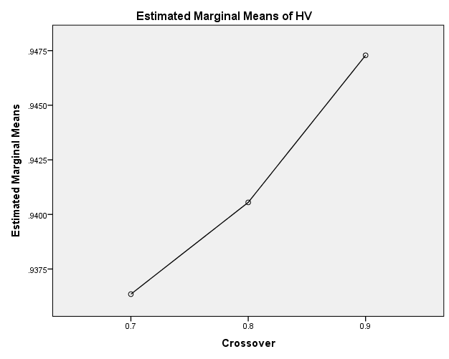

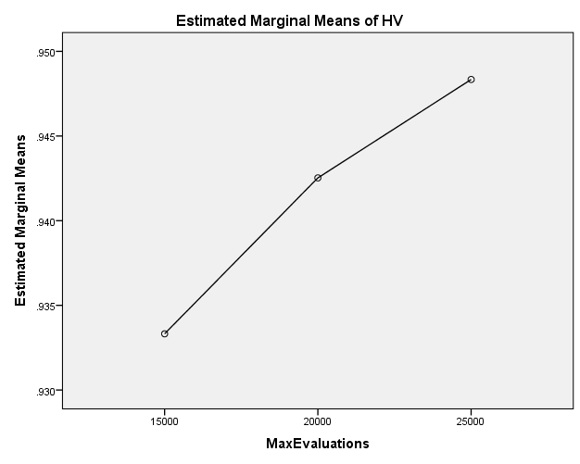

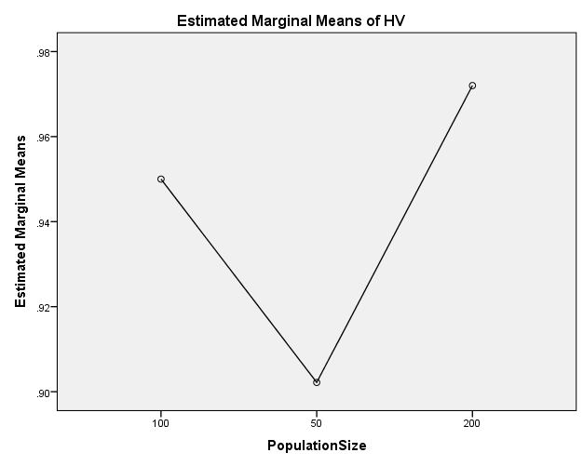

EP

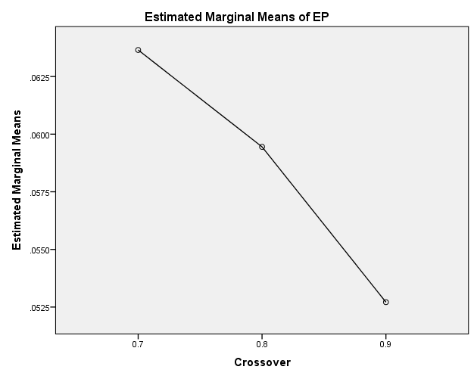

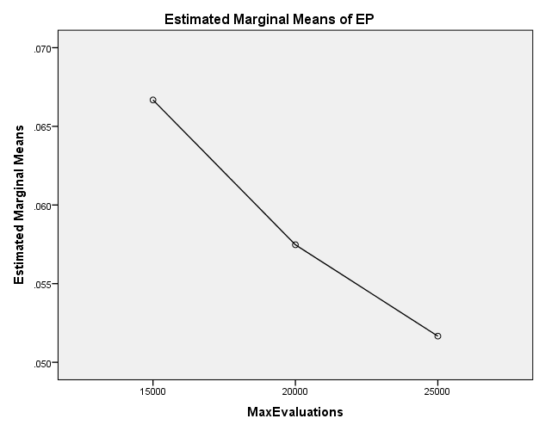

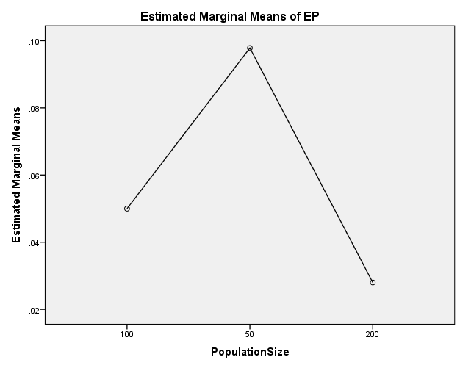

GD

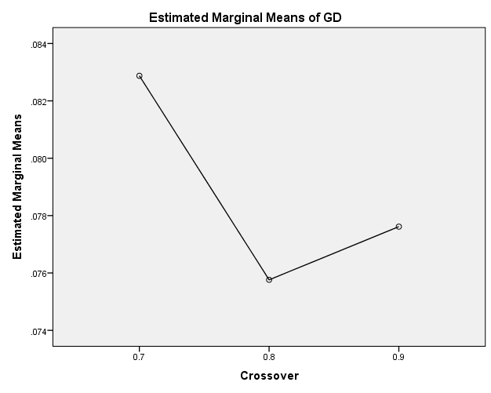

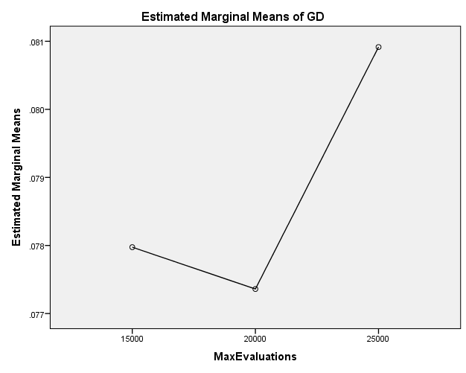

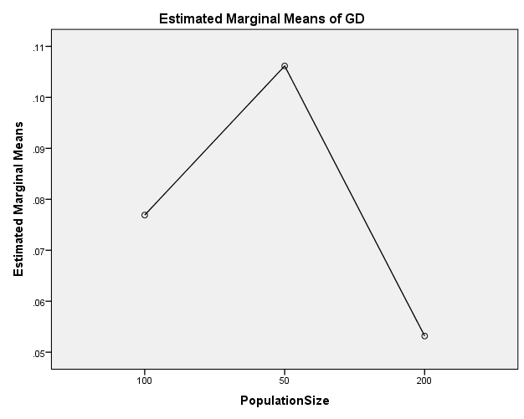

IGD

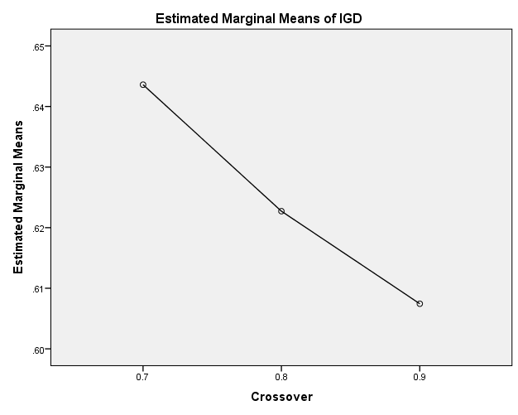

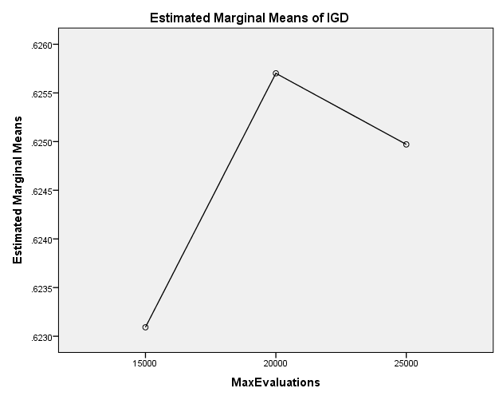

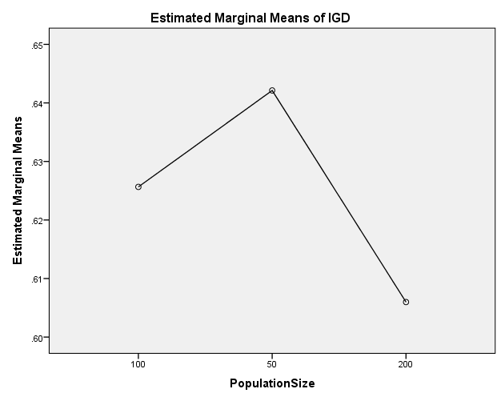

IGDplus

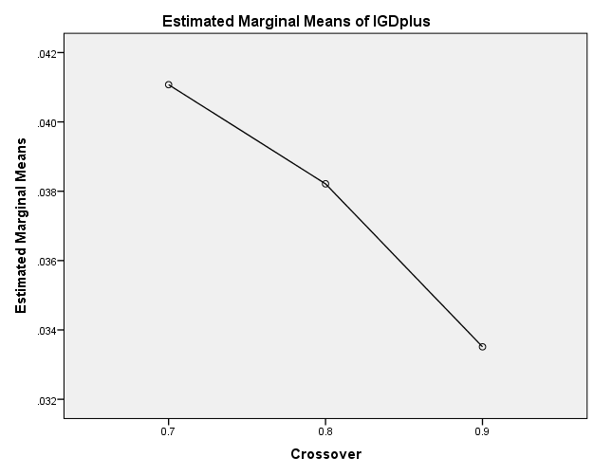

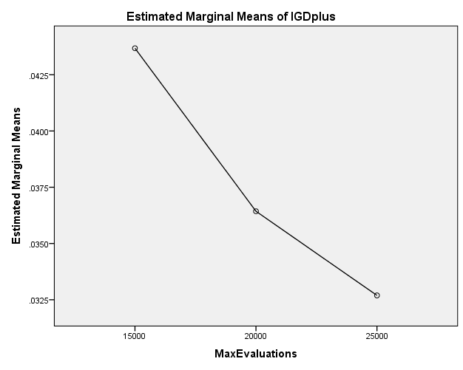

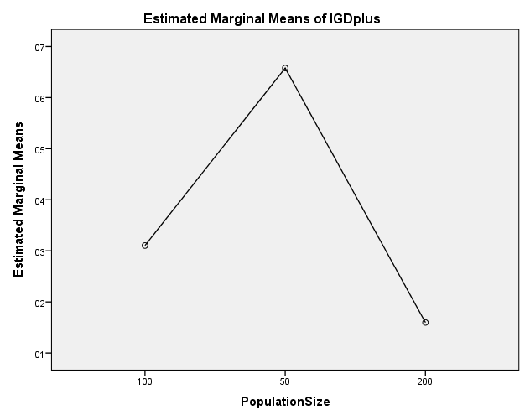

SPREAD

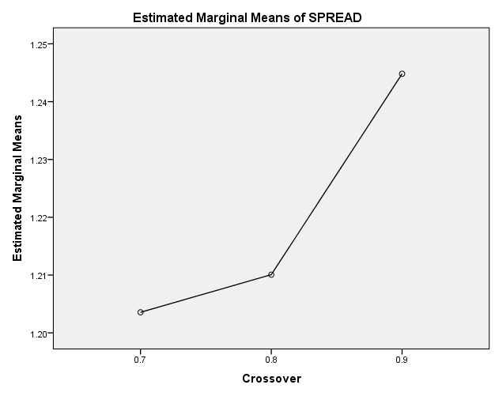

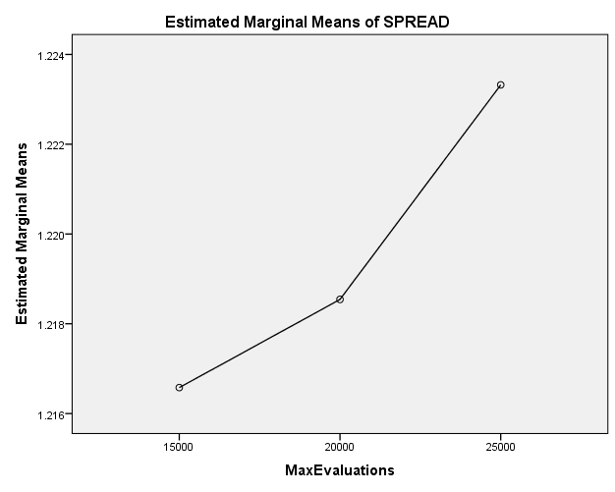

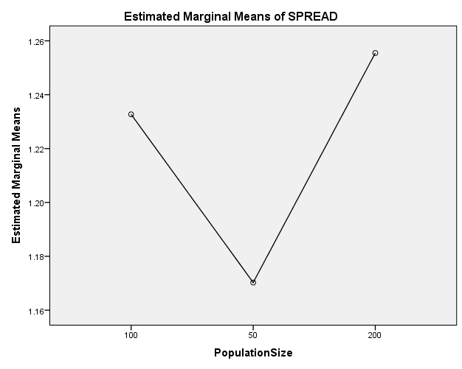

EXAMINE VARIABLES=HV EP GD IGD IGDplus SPREAD BY Crossover MaxEvaluations PopulationSize
/PLOT BOXPLOT
/COMPARE VARIABLES
/STATISTICS NONE
/CINTERVAL 95
/MISSING LISTWISE
/NOTOTAL.

Explore

Notes
Output Created |  | 26-MAY-2020 20:20:15
Comments
Input | Data | C:\Users\user\Documents\NILAY\Mayis2020\7_NSGAII.sav
Input | Active Dataset | DataSet2
Input | Filter | <none>
Input | Weight | <none>
Input | Split File | <none>
Input | N of Rows in Working Data File | 837
Missing Value Handling | Definition of Missing | User-defined missing values for dependent variables are treated as missing.
Missing Value Handling | Cases Used | Statistics are based on cases with no missing values for any dependent variable or factor used.
Syntax |  | EXAMINE VARIABLES=HV EP GD IGD IGDplus SPREAD BY Crossover MaxEvaluations PopulationSize  /PLOT BOXPLOT  /COMPARE VARIABLES  /STATISTICS NONE  /CINTERVAL 95  /MISSING LISTWISE  /NOTOTAL.
Resources | Processor Time | 00:00:01.66
Resources | Elapsed Time | 00:00:01.66

[DataSet2] C:\Users\user\Documents\NILAY\Mayis2020\7_NSGAII.sav

Crossover

Case Processing Summary
 | Crossover | Cases
 | Crossover | Valid |  | Missing |  | Total
 | Crossover | N | Percent | N | Percent | N | Percent
HV | 0.7 | 279 | 100.0% | 0 | 0.0% | 279 | 100.0%
HV | 0.8 | 279 | 100.0% | 0 | 0.0% | 279 | 100.0%
HV | 0.9 | 279 | 100.0% | 0 | 0.0% | 279 | 100.0%
EP | 0.7 | 279 | 100.0% | 0 | 0.0% | 279 | 100.0%
EP | 0.8 | 279 | 100.0% | 0 | 0.0% | 279 | 100.0%
EP | 0.9 | 279 | 100.0% | 0 | 0.0% | 279 | 100.0%
GD | 0.7 | 279 | 100.0% | 0 | 0.0% | 279 | 100.0%
GD | 0.8 | 279 | 100.0% | 0 | 0.0% | 279 | 100.0%
GD | 0.9 | 279 | 100.0% | 0 | 0.0% | 279 | 100.0%
IGD | 0.7 | 279 | 100.0% | 0 | 0.0% | 279 | 100.0%
IGD | 0.8 | 279 | 100.0% | 0 | 0.0% | 279 | 100.0%
IGD | 0.9 | 279 | 100.0% | 0 | 0.0% | 279 | 100.0%
IGDplus | 0.7 | 279 | 100.0% | 0 | 0.0% | 279 | 100.0%
IGDplus | 0.8 | 279 | 100.0% | 0 | 0.0% | 279 | 100.0%
IGDplus | 0.9 | 279 | 100.0% | 0 | 0.0% | 279 | 100.0%
SPREAD | 0.7 | 279 | 100.0% | 0 | 0.0% | 279 | 100.0%
SPREAD | 0.8 | 279 | 100.0% | 0 | 0.0% | 279 | 100.0%
SPREAD | 0.9 | 279 | 100.0% | 0 | 0.0% | 279 | 100.0%

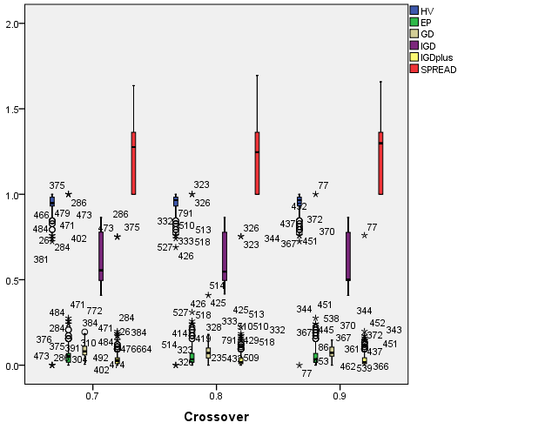

MaxEvaluations

Case Processing Summary
 | MaxEvaluations | Cases
 | MaxEvaluations | Valid |  | Missing |  | Total
 | MaxEvaluations | N | Percent | N | Percent | N | Percent
HV | 15000 | 279 | 100.0% | 0 | 0.0% | 279 | 100.0%
HV | 20000 | 279 | 100.0% | 0 | 0.0% | 279 | 100.0%
HV | 25000 | 279 | 100.0% | 0 | 0.0% | 279 | 100.0%
EP | 15000 | 279 | 100.0% | 0 | 0.0% | 279 | 100.0%
EP | 20000 | 279 | 100.0% | 0 | 0.0% | 279 | 100.0%
EP | 25000 | 279 | 100.0% | 0 | 0.0% | 279 | 100.0%
GD | 15000 | 279 | 100.0% | 0 | 0.0% | 279 | 100.0%
GD | 20000 | 279 | 100.0% | 0 | 0.0% | 279 | 100.0%
GD | 25000 | 279 | 100.0% | 0 | 0.0% | 279 | 100.0%
IGD | 15000 | 279 | 100.0% | 0 | 0.0% | 279 | 100.0%
IGD | 20000 | 279 | 100.0% | 0 | 0.0% | 279 | 100.0%
IGD | 25000 | 279 | 100.0% | 0 | 0.0% | 279 | 100.0%
IGDplus | 15000 | 279 | 100.0% | 0 | 0.0% | 279 | 100.0%
IGDplus | 20000 | 279 | 100.0% | 0 | 0.0% | 279 | 100.0%
IGDplus | 25000 | 279 | 100.0% | 0 | 0.0% | 279 | 100.0%
SPREAD | 15000 | 279 | 100.0% | 0 | 0.0% | 279 | 100.0%
SPREAD | 20000 | 279 | 100.0% | 0 | 0.0% | 279 | 100.0%
SPREAD | 25000 | 279 | 100.0% | 0 | 0.0% | 279 | 100.0%

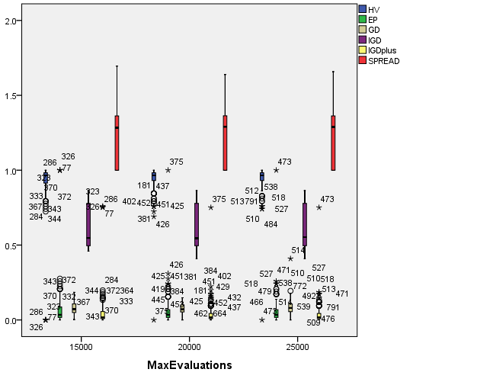

PopulationSize

Case Processing Summary
 | PopulationSize | Cases
 | PopulationSize | Valid |  | Missing |  | Total
 | PopulationSize | N | Percent | N | Percent | N | Percent
HV | 100 | 279 | 100.0% | 0 | 0.0% | 279 | 100.0%
HV | 50 | 279 | 100.0% | 0 | 0.0% | 279 | 100.0%
HV | 200 | 279 | 100.0% | 0 | 0.0% | 279 | 100.0%
EP | 100 | 279 | 100.0% | 0 | 0.0% | 279 | 100.0%
EP | 50 | 279 | 100.0% | 0 | 0.0% | 279 | 100.0%
EP | 200 | 279 | 100.0% | 0 | 0.0% | 279 | 100.0%
GD | 100 | 279 | 100.0% | 0 | 0.0% | 279 | 100.0%
GD | 50 | 279 | 100.0% | 0 | 0.0% | 279 | 100.0%
GD | 200 | 279 | 100.0% | 0 | 0.0% | 279 | 100.0%
IGD | 100 | 279 | 100.0% | 0 | 0.0% | 279 | 100.0%
IGD | 50 | 279 | 100.0% | 0 | 0.0% | 279 | 100.0%
IGD | 200 | 279 | 100.0% | 0 | 0.0% | 279 | 100.0%
IGDplus | 100 | 279 | 100.0% | 0 | 0.0% | 279 | 100.0%
IGDplus | 50 | 279 | 100.0% | 0 | 0.0% | 279 | 100.0%
IGDplus | 200 | 279 | 100.0% | 0 | 0.0% | 279 | 100.0%
SPREAD | 100 | 279 | 100.0% | 0 | 0.0% | 279 | 100.0%
SPREAD | 50 | 279 | 100.0% | 0 | 0.0% | 279 | 100.0%
SPREAD | 200 | 279 | 100.0% | 0 | 0.0% | 279 | 100.0%

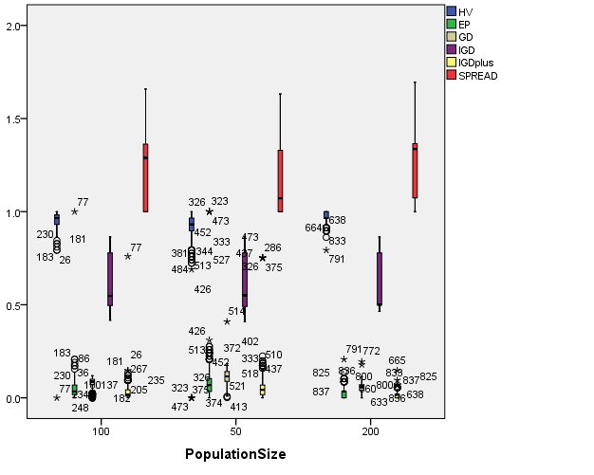

EXAMINE VARIABLES=HV EP GD IGD IGDplus SPREAD BY Crossover MaxEvaluations PopulationSize
/PLOT BOXPLOT
/COMPARE GROUPS
/STATISTICS NONE
/CINTERVAL 95
/MISSING LISTWISE
/NOTOTAL.

Explore

Notes
Output Created |  | 26-MAY-2020 20:20:48
Comments
Input | Data | C:\Users\user\Documents\NILAY\Mayis2020\7_NSGAII.sav
Input | Active Dataset | DataSet2
Input | Filter | <none>
Input | Weight | <none>
Input | Split File | <none>
Input | N of Rows in Working Data File | 837
Missing Value Handling | Definition of Missing | User-defined missing values for dependent variables are treated as missing.
Missing Value Handling | Cases Used | Statistics are based on cases with no missing values for any dependent variable or factor used.
Syntax |  | EXAMINE VARIABLES=HV EP GD IGD IGDplus SPREAD BY Crossover MaxEvaluations PopulationSize  /PLOT BOXPLOT  /COMPARE GROUPS  /STATISTICS NONE  /CINTERVAL 95  /MISSING LISTWISE  /NOTOTAL.
Resources | Processor Time | 00:00:04.00
Resources | Elapsed Time | 00:00:03.94

[DataSet2] C:\Users\user\Documents\NILAY\Mayis2020\7_NSGAII.sav

Crossover

Case Processing Summary
 | Crossover | Cases
 | Crossover | Valid |  | Missing |  | Total
 | Crossover | N | Percent | N | Percent | N | Percent
HV | 0.7 | 279 | 100.0% | 0 | 0.0% | 279 | 100.0%
HV | 0.8 | 279 | 100.0% | 0 | 0.0% | 279 | 100.0%
HV | 0.9 | 279 | 100.0% | 0 | 0.0% | 279 | 100.0%
EP | 0.7 | 279 | 100.0% | 0 | 0.0% | 279 | 100.0%
EP | 0.8 | 279 | 100.0% | 0 | 0.0% | 279 | 100.0%
EP | 0.9 | 279 | 100.0% | 0 | 0.0% | 279 | 100.0%
GD | 0.7 | 279 | 100.0% | 0 | 0.0% | 279 | 100.0%
GD | 0.8 | 279 | 100.0% | 0 | 0.0% | 279 | 100.0%
GD | 0.9 | 279 | 100.0% | 0 | 0.0% | 279 | 100.0%
IGD | 0.7 | 279 | 100.0% | 0 | 0.0% | 279 | 100.0%
IGD | 0.8 | 279 | 100.0% | 0 | 0.0% | 279 | 100.0%
IGD | 0.9 | 279 | 100.0% | 0 | 0.0% | 279 | 100.0%
IGDplus | 0.7 | 279 | 100.0% | 0 | 0.0% | 279 | 100.0%
IGDplus | 0.8 | 279 | 100.0% | 0 | 0.0% | 279 | 100.0%
IGDplus | 0.9 | 279 | 100.0% | 0 | 0.0% | 279 | 100.0%
SPREAD | 0.7 | 279 | 100.0% | 0 | 0.0% | 279 | 100.0%
SPREAD | 0.8 | 279 | 100.0% | 0 | 0.0% | 279 | 100.0%
SPREAD | 0.9 | 279 | 100.0% | 0 | 0.0% | 279 | 100.0%

HV

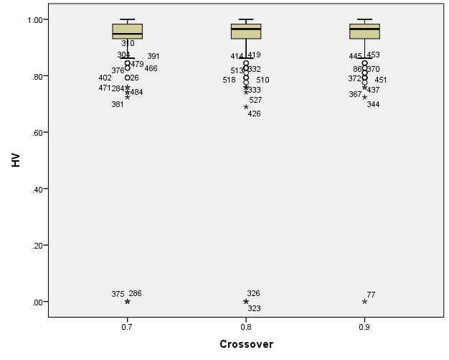

EP

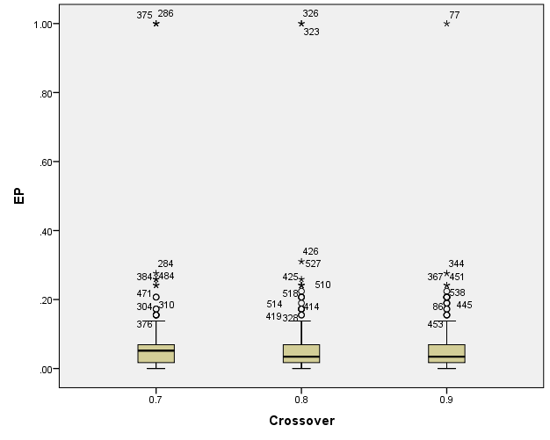

GD

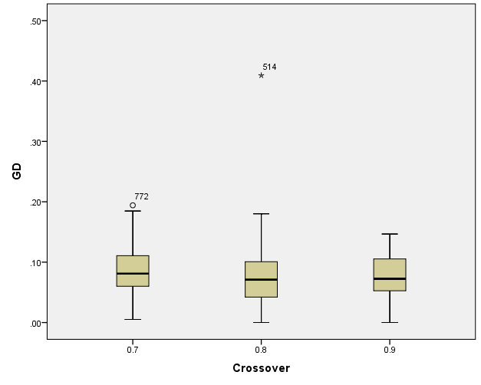

IGD

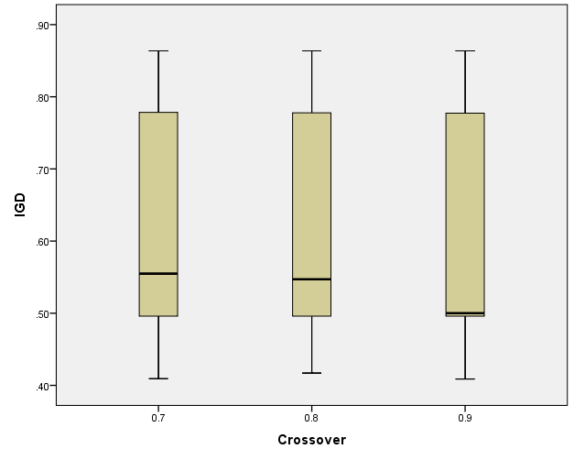

IGDplus

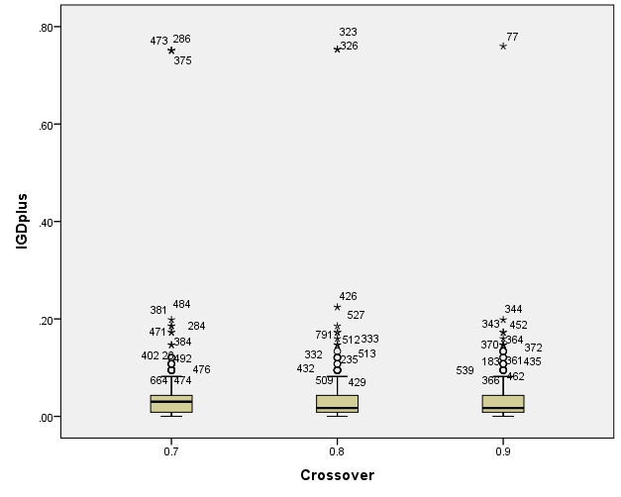

SPREAD

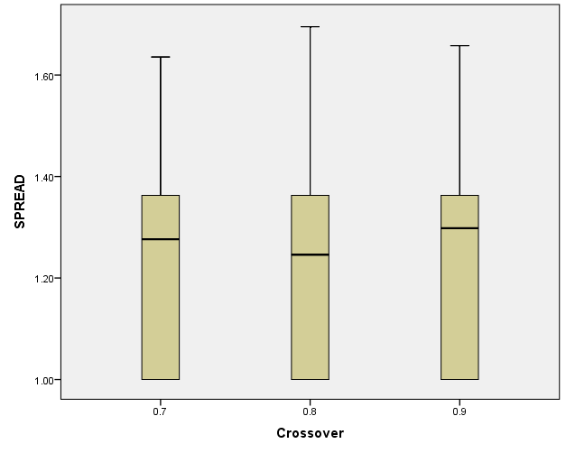

MaxEvaluations

Case Processing Summary
 | MaxEvaluations | Cases
 | MaxEvaluations | Valid |  | Missing |  | Total
 | MaxEvaluations | N | Percent | N | Percent | N | Percent
HV | 15000 | 279 | 100.0% | 0 | 0.0% | 279 | 100.0%
HV | 20000 | 279 | 100.0% | 0 | 0.0% | 279 | 100.0%
HV | 25000 | 279 | 100.0% | 0 | 0.0% | 279 | 100.0%
EP | 15000 | 279 | 100.0% | 0 | 0.0% | 279 | 100.0%
EP | 20000 | 279 | 100.0% | 0 | 0.0% | 279 | 100.0%
EP | 25000 | 279 | 100.0% | 0 | 0.0% | 279 | 100.0%
GD | 15000 | 279 | 100.0% | 0 | 0.0% | 279 | 100.0%
GD | 20000 | 279 | 100.0% | 0 | 0.0% | 279 | 100.0%
GD | 25000 | 279 | 100.0% | 0 | 0.0% | 279 | 100.0%
IGD | 15000 | 279 | 100.0% | 0 | 0.0% | 279 | 100.0%
IGD | 20000 | 279 | 100.0% | 0 | 0.0% | 279 | 100.0%
IGD | 25000 | 279 | 100.0% | 0 | 0.0% | 279 | 100.0%
IGDplus | 15000 | 279 | 100.0% | 0 | 0.0% | 279 | 100.0%
IGDplus | 20000 | 279 | 100.0% | 0 | 0.0% | 279 | 100.0%
IGDplus | 25000 | 279 | 100.0% | 0 | 0.0% | 279 | 100.0%
SPREAD | 15000 | 279 | 100.0% | 0 | 0.0% | 279 | 100.0%
SPREAD | 20000 | 279 | 100.0% | 0 | 0.0% | 279 | 100.0%
SPREAD | 25000 | 279 | 100.0% | 0 | 0.0% | 279 | 100.0%

HV

Boxplots

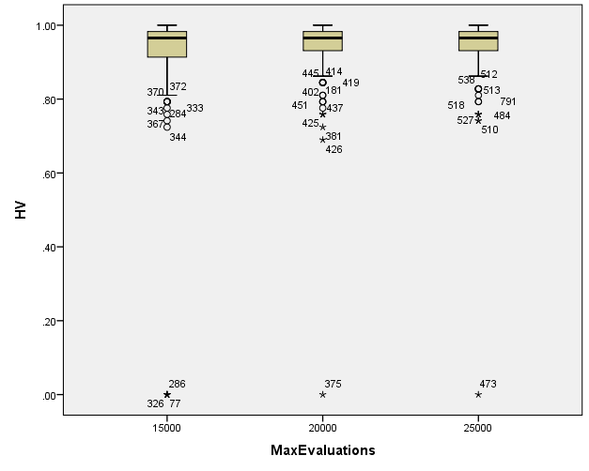

EP

Boxplots

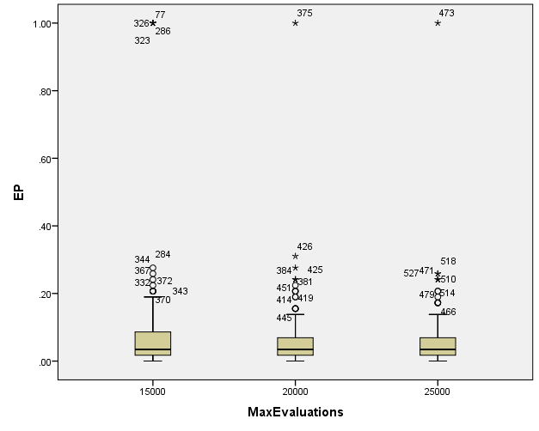

GD

Boxplots

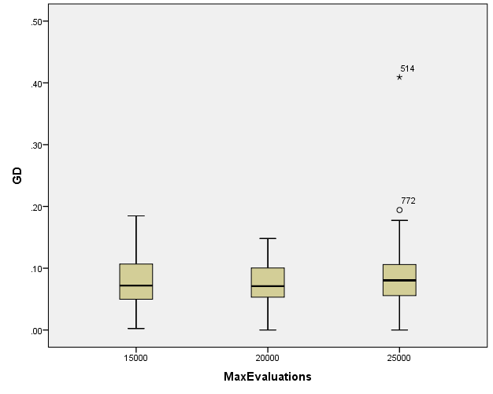

IGD

Boxplots

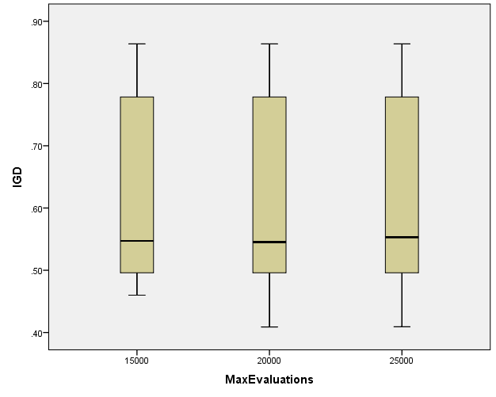

IGDplus

Boxplots

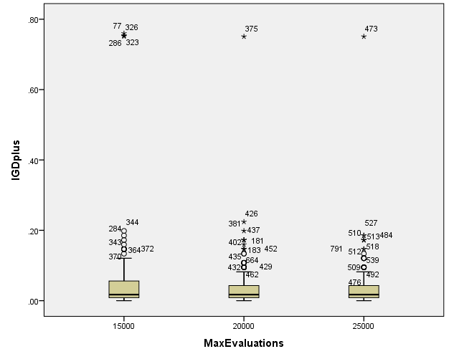

SPREAD

Boxplots

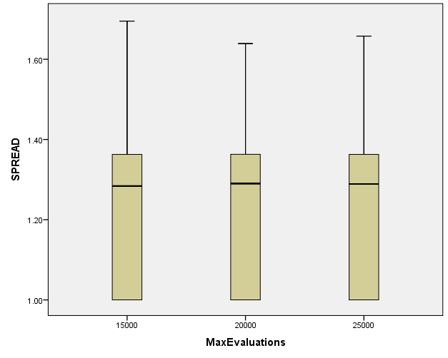

PopulationSize

Case Processing Summary
 | PopulationSize | Cases
 | PopulationSize | Valid |  | Missing |  | Total
 | PopulationSize | N | Percent | N | Percent | N | Percent
HV | 100 | 279 | 100.0% | 0 | 0.0% | 279 | 100.0%
HV | 50 | 279 | 100.0% | 0 | 0.0% | 279 | 100.0%
HV | 200 | 279 | 100.0% | 0 | 0.0% | 279 | 100.0%
EP | 100 | 279 | 100.0% | 0 | 0.0% | 279 | 100.0%
EP | 50 | 279 | 100.0% | 0 | 0.0% | 279 | 100.0%
EP | 200 | 279 | 100.0% | 0 | 0.0% | 279 | 100.0%
GD | 100 | 279 | 100.0% | 0 | 0.0% | 279 | 100.0%
GD | 50 | 279 | 100.0% | 0 | 0.0% | 279 | 100.0%
GD | 200 | 279 | 100.0% | 0 | 0.0% | 279 | 100.0%
IGD | 100 | 279 | 100.0% | 0 | 0.0% | 279 | 100.0%
IGD | 50 | 279 | 100.0% | 0 | 0.0% | 279 | 100.0%
IGD | 200 | 279 | 100.0% | 0 | 0.0% | 279 | 100.0%
IGDplus | 100 | 279 | 100.0% | 0 | 0.0% | 279 | 100.0%
IGDplus | 50 | 279 | 100.0% | 0 | 0.0% | 279 | 100.0%
IGDplus | 200 | 279 | 100.0% | 0 | 0.0% | 279 | 100.0%
SPREAD | 100 | 279 | 100.0% | 0 | 0.0% | 279 | 100.0%
SPREAD | 50 | 279 | 100.0% | 0 | 0.0% | 279 | 100.0%
SPREAD | 200 | 279 | 100.0% | 0 | 0.0% | 279 | 100.0%

HV

Boxplots

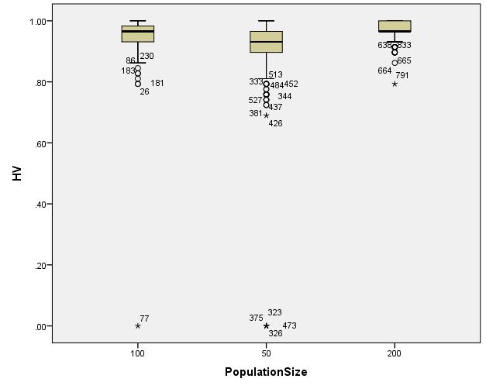

EP

Boxplots

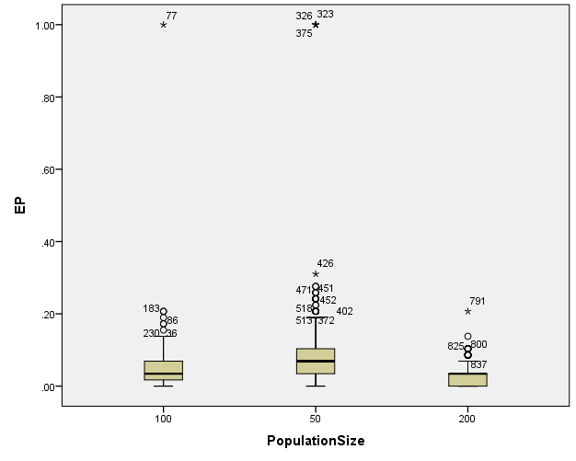

GD

Boxplots

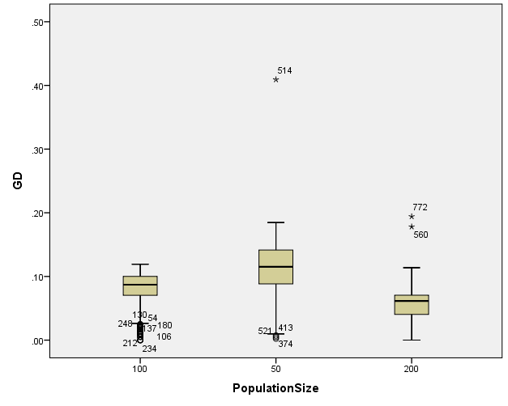

IGD

Boxplots

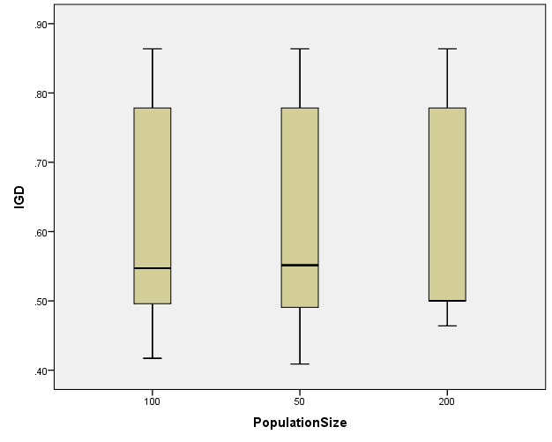

IGDplus

Boxplots

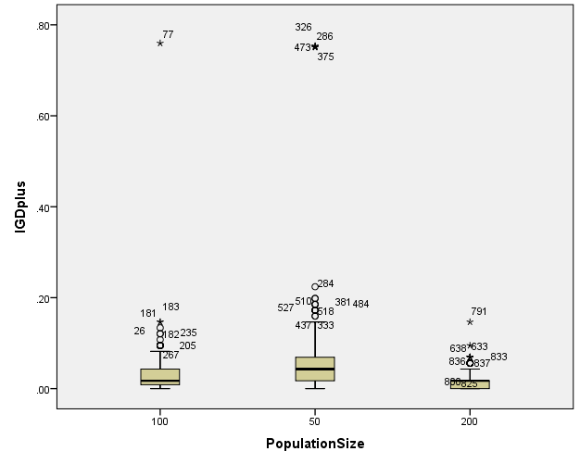

SPREAD

Boxplots

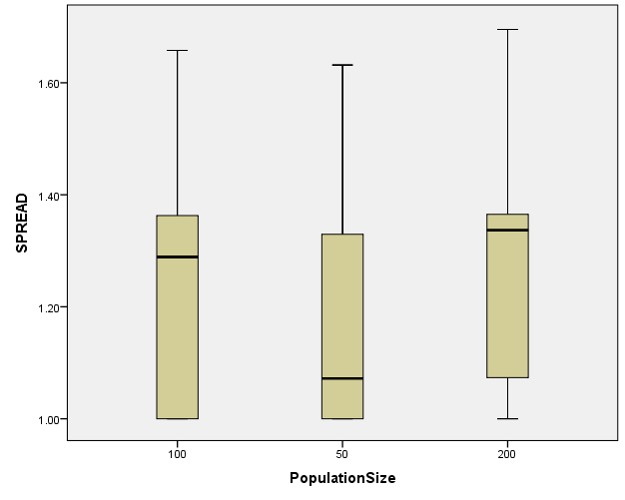

*Nonparametric Tests: Independent Samples.
NPTESTS
/INDEPENDENT TEST (HV EP GD IGD IGDplus SPREAD) GROUP (Crossover) MEDIAN(TESTVALUE=SAMPLE COMPARE=PAIRWISE)
/MISSING SCOPE=ANALYSIS USERMISSING=EXCLUDE
/CRITERIA ALPHA=0.05 CILEVEL=95.

Nonparametric Tests

Notes
Output Created |  | 26-MAY-2020 20:22:39
Comments
Input | Data | C:\Users\user\Documents\NILAY\Mayis2020\7_NSGAII.sav
Input | Active Dataset | DataSet2
Input | Filter | <none>
Input | Weight | <none>
Input | Split File | <none>
Input | N of Rows in Working Data File | 837
Syntax |  | NPTESTS  /INDEPENDENT TEST (HV EP GD IGD IGDplus SPREAD) GROUP (Crossover) MEDIAN(TESTVALUE=SAMPLE COMPARE=PAIRWISE)  /MISSING SCOPE=ANALYSIS USERMISSING=EXCLUDE  /CRITERIA ALPHA=0.05 CILEVEL=95.
Resources | Processor Time | 00:00:00.16
Resources | Elapsed Time | 00:00:00.21

[DataSet2] C:\Users\user\Documents\NILAY\Mayis2020\7_NSGAII.sav

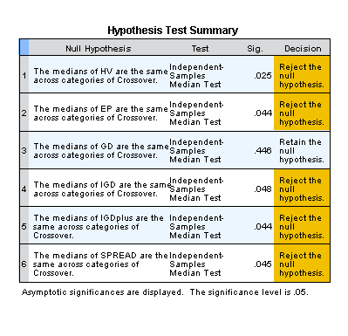

*Nonparametric Tests: Independent Samples.
NPTESTS
/INDEPENDENT TEST (HV EP GD IGD IGDplus SPREAD) GROUP (MaxEvaluations) MEDIAN(TESTVALUE=SAMPLE COMPARE=PAIRWISE)
/MISSING SCOPE=ANALYSIS USERMISSING=EXCLUDE
/CRITERIA ALPHA=0.05 CILEVEL=95.

Nonparametric Tests

Notes
Output Created |  | 26-MAY-2020 20:22:52
Comments
Input | Data | C:\Users\user\Documents\NILAY\Mayis2020\7_NSGAII.sav
Input | Active Dataset | DataSet2
Input | Filter | <none>
Input | Weight | <none>
Input | Split File | <none>
Input | N of Rows in Working Data File | 837
Syntax |  | NPTESTS  /INDEPENDENT TEST (HV EP GD IGD IGDplus SPREAD) GROUP (MaxEvaluations) MEDIAN(TESTVALUE=SAMPLE COMPARE=PAIRWISE)  /MISSING SCOPE=ANALYSIS USERMISSING=EXCLUDE  /CRITERIA ALPHA=0.05 CILEVEL=95.
Resources | Processor Time | 00:00:00.13
Resources | Elapsed Time | 00:00:00.14

[DataSet2] C:\Users\user\Documents\NILAY\Mayis2020\7_NSGAII.sav

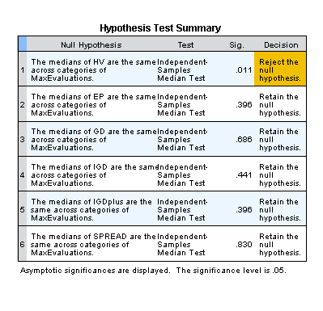

*Nonparametric Tests: Independent Samples.
NPTESTS
/INDEPENDENT TEST (HV EP GD IGD IGDplus SPREAD) GROUP (PopulationSize) MEDIAN(TESTVALUE=SAMPLE COMPARE=PAIRWISE)
/MISSING SCOPE=ANALYSIS USERMISSING=EXCLUDE
/CRITERIA ALPHA=0.05 CILEVEL=95.

Nonparametric Tests

Notes
Output Created |  | 26-MAY-2020 20:23:09
Comments
Input | Data | C:\Users\user\Documents\NILAY\Mayis2020\7_NSGAII.sav
Input | Active Dataset | DataSet2
Input | Filter | <none>
Input | Weight | <none>
Input | Split File | <none>
Input | N of Rows in Working Data File | 837
Syntax |  | NPTESTS  /INDEPENDENT TEST (HV EP GD IGD IGDplus SPREAD) GROUP (PopulationSize) MEDIAN(TESTVALUE=SAMPLE COMPARE=PAIRWISE)  /MISSING SCOPE=ANALYSIS USERMISSING=EXCLUDE  /CRITERIA ALPHA=0.05 CILEVEL=95.
Resources | Processor Time | 00:00:00.16
Resources | Elapsed Time | 00:00:00.14

[DataSet2] C:\Users\user\Documents\NILAY\Mayis2020\7_NSGAII.sav

